**Instructions: Can you fix the <hr> tag and align it to the left? (See screen capture below)**

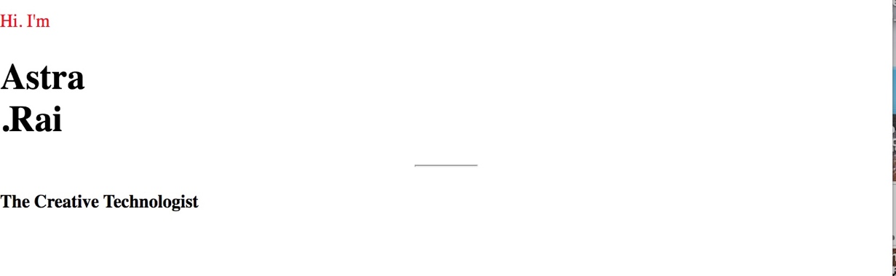

**Notes on <hr> tag**

* <hr> element defines a thematic break in html (e.g. shift of topic)
* border property will add, thickness, height to line
* ex. Border 10px solid red; (did this to make <hr> more visible (see screen capture below)

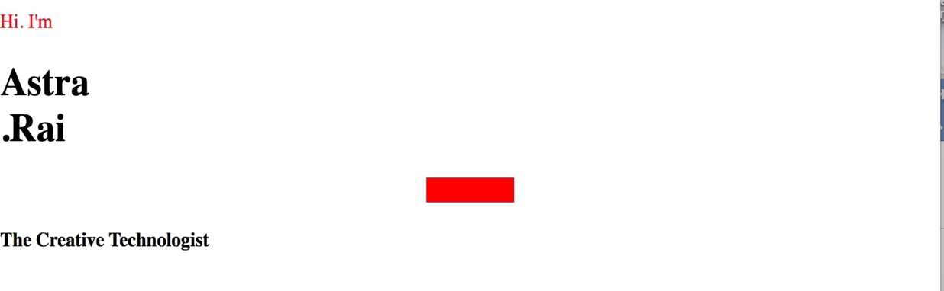

**Action taken to align <hr> to the left:**

Added CSS universal selector (*), the asterisk, to body element.

**Result:**

<hr> tag aligned left

Vertical spacing between elements changed.

Thoughts: Maybe this is related to the margin-top property.

